|  |  |
| --- | --- |
|  | Harmonizing Data with Strategy: Enhancing Customer Engagement through RFM Analysis in Music Streaming |
| Fatima Zahra |
|  |
|  |

**Introduction**

This section introduces the purpose of the RFM analysis, highlighting its importance in understanding customer engagement and segmentation for a music streaming service. Incorporating detailed data descriptions into the RFM Analysis Report enhances the reader's understanding of the dataset's composition and the foundational elements of the analysis. Below is an extended version of the Dataset Description section, including more specifics about the data used for the RFM analysis of the music streaming service.

**Purpose of the RFM Analysis**

The primary objective of conducting the RFM analysis was to segment our customer base in a manner that reveals distinct patterns of engagement and value. This segmentation enables us to tailor our marketing and customer engagement strategies more effectively, maximizing retention, and enhancing the overall value derived from our service. Specifically, the analysis aimed to identify high-value customers deserving of premium engagement strategies, spotlight opportunities within the medium value segment for uplift, and understand the low engagement drivers within the low value segment.

**Dataset Description**

The dataset for the RFM analysis consists of 3,000 records, each representing an individual customer of the music streaming service over a specified period. The dataset includes a variety of metrics, but for the purpose of our analysis, the focus was on the following key attributes:

**Customer ID:** A unique identifier assigned to each customer, facilitating individual analysis and ensuring privacy. This field is numeric and serves as the primary key for the dataset.

**Date of Last Stream:** Indicates the most recent date on which a customer streamed music. This field is critical for calculating the Recency aspect of the RFM model. Dates range over the last several months, providing insight into recent customer engagement.

**Number of Streams:** Represents the total count of streams by each customer. This metric is used to assess the Frequency component of the RFM model, indicating how often a customer engages with the streaming service. The range varies widely, reflecting different levels of user engagement.

**Total Streaming Time (hours):** Quantifies the total amount of time (in hours) that a customer has spent streaming music. This metric is used as a proxy for the Monetary value in the RFM analysis, under the assumption that more time spent streaming correlates with higher engagement and, potentially, higher value to the service through ad revenue or subscription fees.

**Enhanced Understanding Through Visuals**

* The RFM Segment Distribution visual highlighted the predominance of the Medium Value segment, suggesting a significant opportunity for targeted marketing strategies to elevate these customers to High Value.
* The Correlation Matrix within the Champions segment revealed nuanced relationships between the RFM metrics, offering a deeper understanding of what drives engagement among our most valuable customers.
* The Comparison of RFM Segments through grouped bar charts demonstrated clear distinctions in engagement levels across segments, reinforcing the importance of differentiated engagement strategies.

**Sample Data Snapshot:**

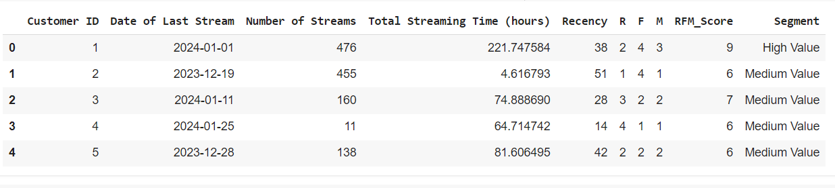

This detailed description provides a comprehensive overview of the dataset, laying the groundwork for understanding the subsequent RFM analysis and ensuring that the methodology and findings are grounded in a clear context.